A BIG SLICE OF PI

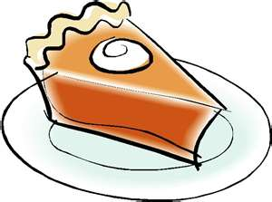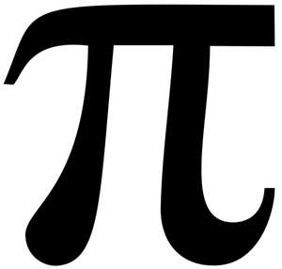

A POEM WRITTEN BY
MARC A. UMILE

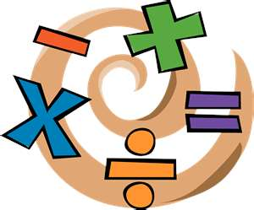

There exists a subject
That’s crossed our path
We all know it well
It’s a part of math
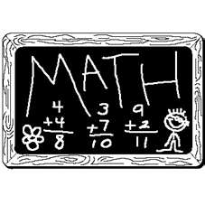
We know what math is
We had it in school
But it’s not hard to learn
I think it’s kinda cool

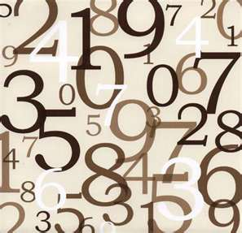

It’s a special number
That has been found
To measure a shape
We all know to be round



A circle, of course
Is what I mean
The most mystical shape
We’ve ever seen

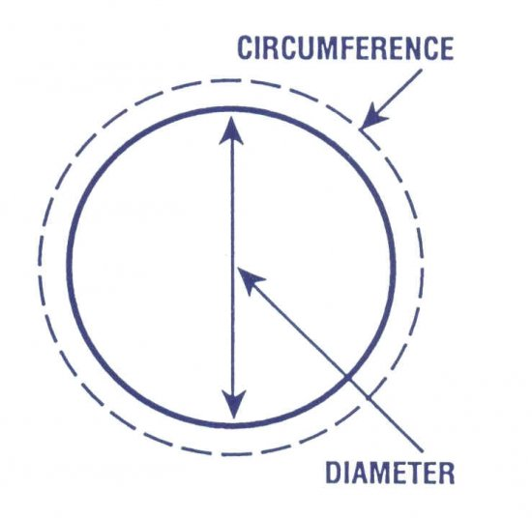
Its length across
Is diameter D
And its distance around
Is Circumference C

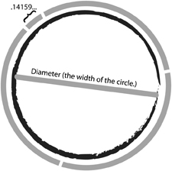

But this number’s purpose
As a ratio, true
Is its known relationship
Between the two

It’s a letter called Pi
From the alphabet of Greece
But its function in math
It will never cease

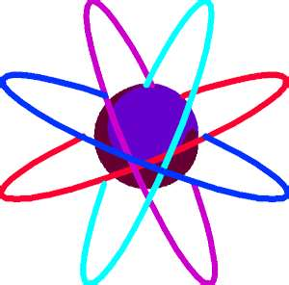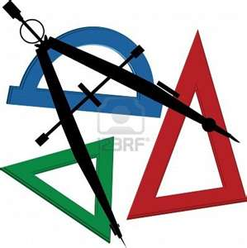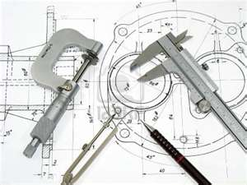

Known also in physics
And geometry, too
And of course in engineering
I figured you knew



No building could stand
No bridge would be sound
If built without Pi
They would fall to the ground

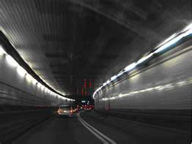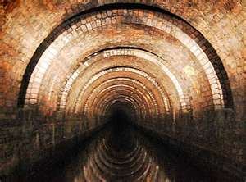

No vehicular tunnel
Or deep waterway
Would pass structural integrity
Without Pi having its say

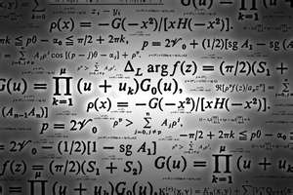

No equation in geometry
Calculus or trig
Would work without Pi
The void would be big


No students in math
Could attain graduation
Without once learning Pi
In their education

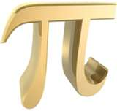

But to gain such knowledge
It’s not much to ask
For how to use the constant
Is a simple task
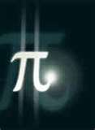

Pi may look daunting
At one’s first glance
But looks can be deceiving
Just give it a chance

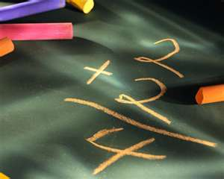

It may not be as basic
As knowing what to do
With a simple equation
Such as two plus two
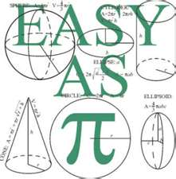

But if you open your mind
And have no fear
What to do with Pi
Will be more than clear

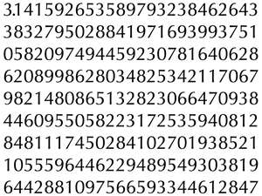

It’s measuring a circle
That’s Pi’s general thing
But the overall attraction
Is its vast digit string
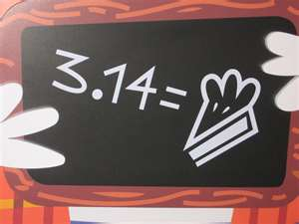

Pi’s decimal expression
Is 3 point 1 4
But the digits continue
So many more

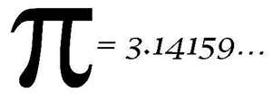
Do you wish to advance?
O.K., that’s fine
How about 3 point
1-4-1-5-9

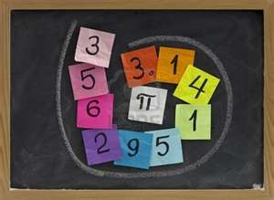

And if that’s not enough
Let’s all make it 3
Point 1-4-1-5
9-2-6-5-3

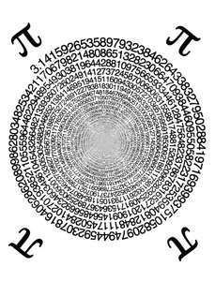
Do these digits end?
The answer is never
They stretch to infinity
They go on forever
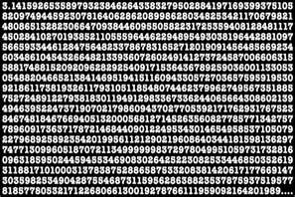

They have no pattern
Or order we can see
It’s a maddening string
Of complexity

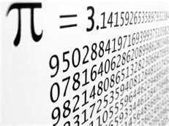

But these digits have purpose
There’s a reason they’re there
If one digit is missing
Then Pi goes nowhere

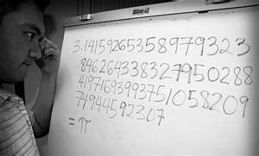

Say 3 point 1 2
Instead of 3 point 1 4
And Pi would be useless
And pointless for sure

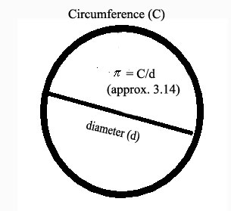

This is how we use Pi
I’ll explain it from here
In measuring a circle
And even a sphere

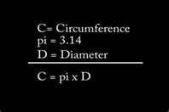

To find the circumference
On this you can rely
Simply take the diameter
And times it by Pi

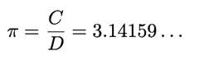
If you divide the circumference
By 3 point 1 4
You’ll get the diameter
Of the circle for sure

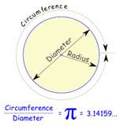

Regardless if the circle
Is big or small
This principle applies
To one and all



But how many digits
Are really required
In order to have
Good accuracy acquired?

3.14159265358
9793238462643
383279502884
19716939937510…

No proper measurement
Should really demand
Even 50 digits
For all of it to stand



The skilled engineer
Would need no more than 8
For the obsessive physicist
More than 20 would overrate

3.1415926535897…
But remember in Pi
For each new digit past
It raises the value 10 times
More precise than the last

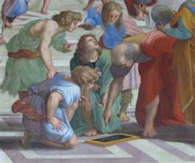

So let us explore
Pi’s illustrious past
It’s evolution through the ages
Is truly vast

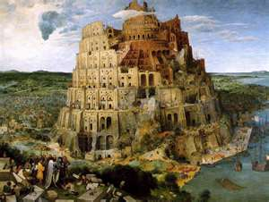

Its history is written
From the days of old
Since ancient Babylon
New facts were told

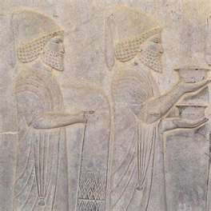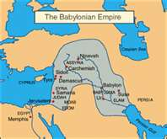

The Babylonians were the first
In 2000 B.C.
To figure a circle’s area
As being somewhere around 3
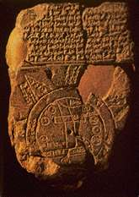

An ancient tablet
Today it does survive
Determined a value
Of 3 point 1 2 5

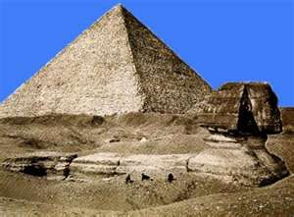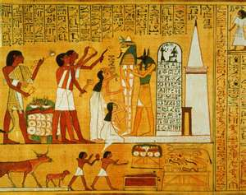

In ancient Egypt
Pi was known to be
Not 3 point 1 4
But simply as 3

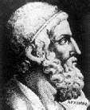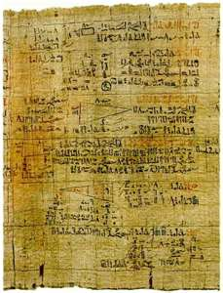

A scribe named Ahmes
Provided documentation
Upon the Rhind Papyrus
Of his approximation
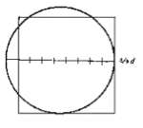
By “Squaring the Circle”
A method he would contrive
The ratio Ahmes found
Was 3.1605

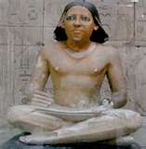

With charisma and zeal
His efforts aimed high
He was off by 1 percent
Of the true value of Pi

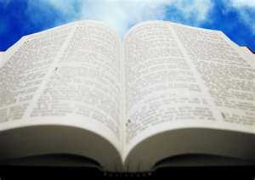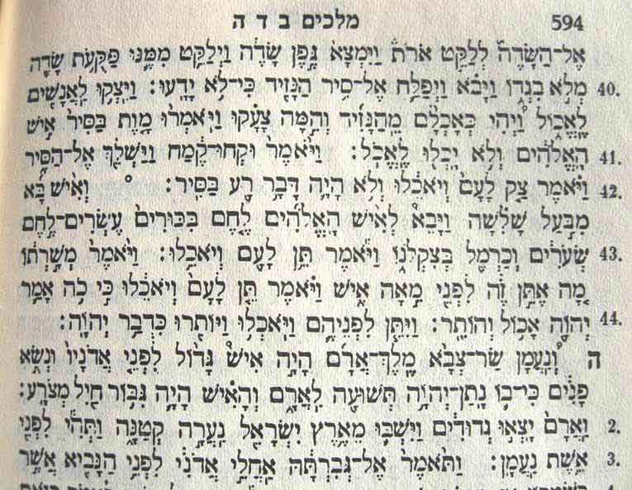

The Bible states
Among other things
That Pi was only 3
In the Book of 1 Kings

I Kings 7:23
This reference appears
Look and you shall see
In Chapter seven
And verse twenty-three

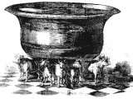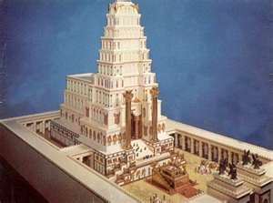

It speaks of an object
Called “The Molten Sea”
In the Temple of Solomon
Where it was known to be

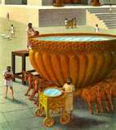

To comprehend the size
Of this valuable treasure
Is to know the Bible’s use
Of a distinct unit of measure

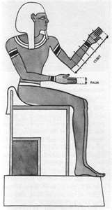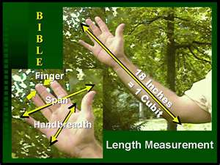

A common cubit
About the length of your arm
Was the measurement used
And it worked like a charm
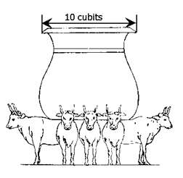
The Molten Sea
Was by no means slim
For it measured 10 cubits
From brim to brim

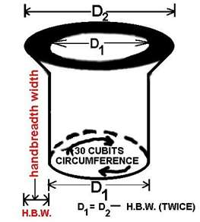

A height of 5 cubits
Made it tall no doubt
While 30 cubits
Encompassed it round about

30/10 = 3

Divide circumference 30
By diameter 10
And a quotient of 3
Will be produced then

Therefore π = 3

So reading this passage
It’s easy to see
How it was determined then
That Pi equaled 3

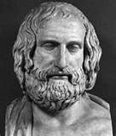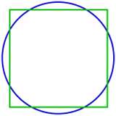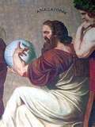

The ingenious Greeks
Had a novel flair
To find a circle’s area
And make it square

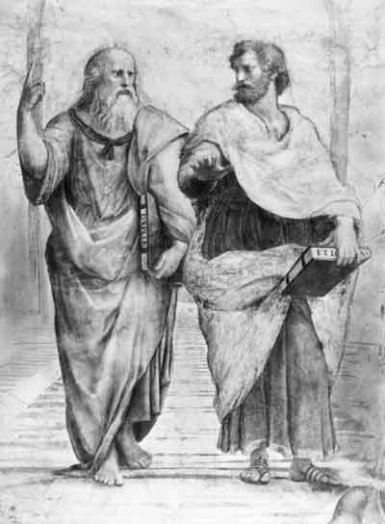

Antiphon and Bryson
Were brilliant in their day
Through their ingenuity
They had much to say
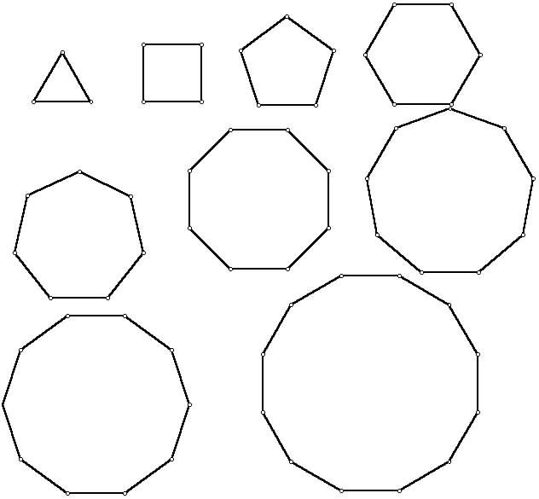

Their theories were solid
And proved validation
As they worked with a shape
Called a polygon formation

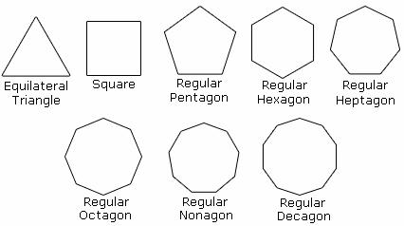

Called the “Method of Exhaustion”
Evidence was found
The more sides they added
The more the shape was round
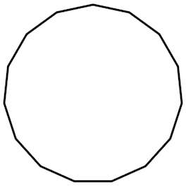

So claiming that a circle
Has corners that are many
Is smarter to say
Than it doesn’t have any



One genius in math
To implement its use
Was old Archimedes
Of Syracuse

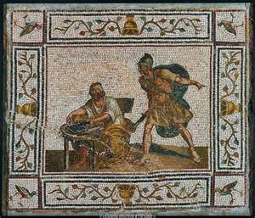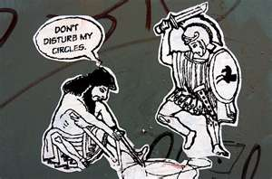

He made new breakthroughs
I’m sure he was thrilled
But at the hands of one Roman
He was sadly killed

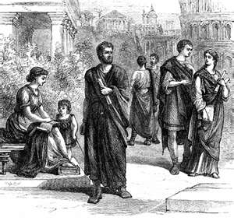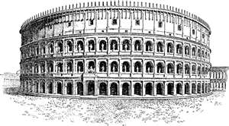

The Romans took part
Said they knew for sure
That Pi’s true value
Was equal to 4

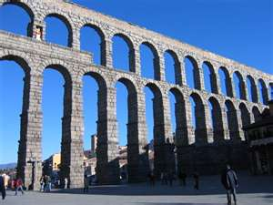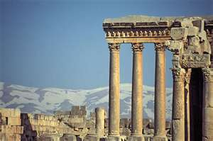

But it makes me wonder
Since this was their vision
How they built their structures
With such great precision

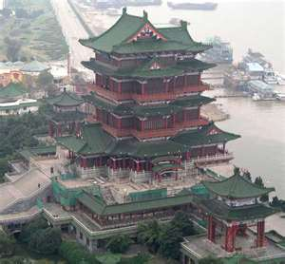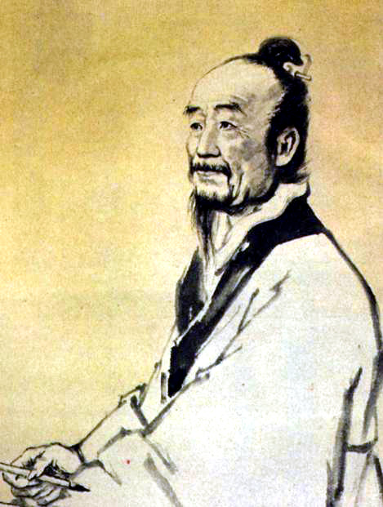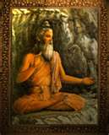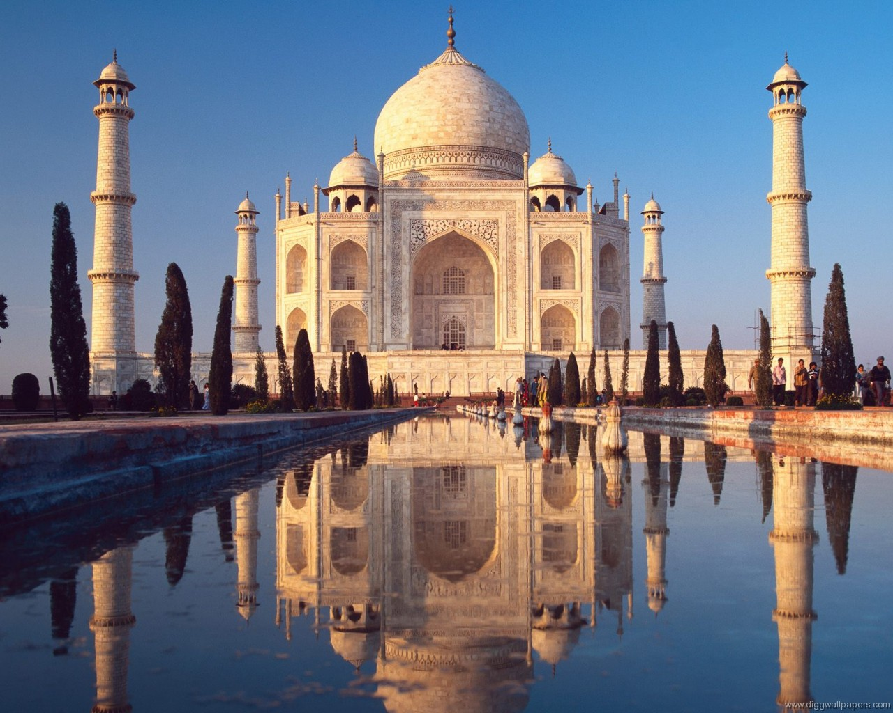

The Chinese tried
The Indians, too
To find a circle’s area
To a value so true

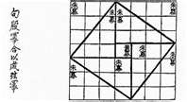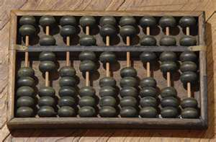

Exploring the circle’s area
Also seemingly with ease
Was by the ancient Empire
Of the Japanese

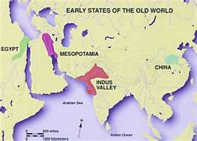

But brilliant as they were
The inhabitants of the East
Pi’s knowledge went forward
Its curiosity never ceased
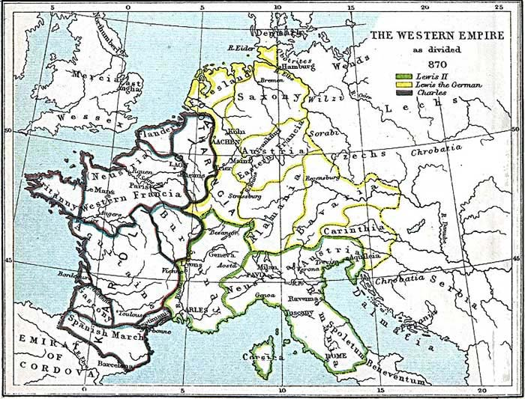

Much more was to be known
And put to the test
By the rising civilization
Occupying the West



Mathematician William Jones
Surely gave us a fix
He gave us the Pi symbol
In 1706
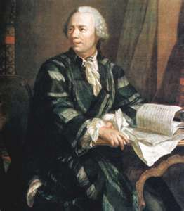

Leonhard Euler
Whose insight seemed greater
Further popularized that symbol
Thirty-one years later

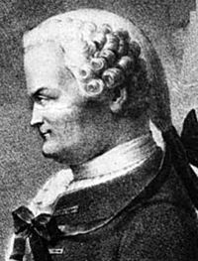

More knowledge of Pi
Was indeed in the air
It was proved irrational
By Johann Lambert (pronounced like “éclair”)

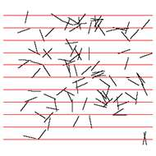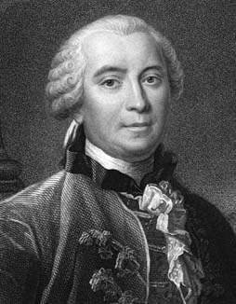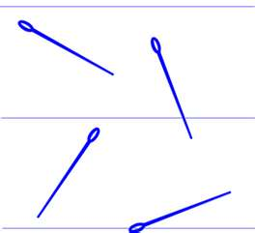

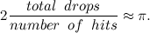

Georges Buffon
Discovered the ability
To estimate Pi
Through statistics of probability

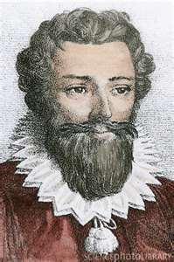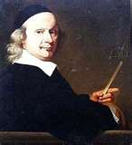

As the knowledge of the value
Moved further West
There came the digit hunters
They did their best

3.14159265358979323846
2643383279502884197169
39937510582097494459230

Finding so many digits
Was their chosen profession
But they did it so much
It became an obsession

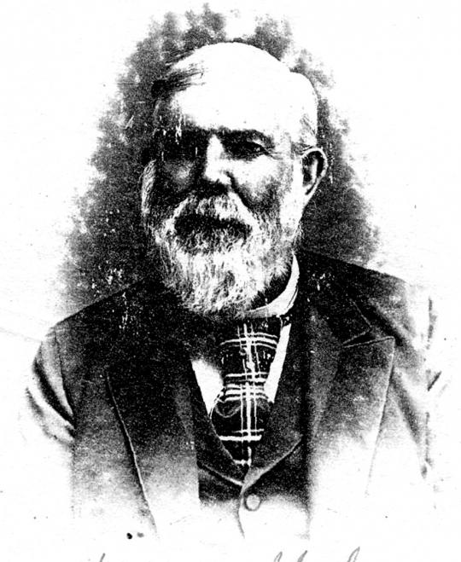
Math genius William Shanks
We thought he did well
His news of 700 digits
Spread like hell

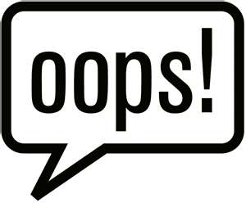

But D. F. Ferguson
Was sorry to state
Shanks digits were wrong
At five twenty-eight

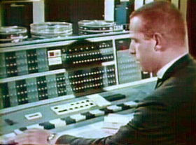

From the Victorian Era
To the Computer Age
The number of digits
Filled up more than one page

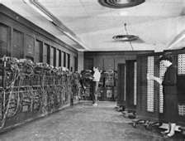

The ENIAC Computer
Spit 2,000 of them
But hundreds of thousands
Were by IBM

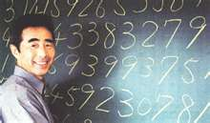

The race continued
By so many others
Kanada from Japan
Even the Chudnovsky Brothers

3 POINT +
10,000,000,000,000!!!
10 trillion digits
As if sent from Heaven
Was recorded one day
In two-thousand eleven

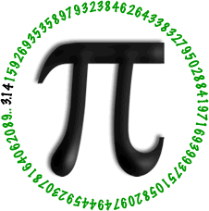

Pi’s history is vast
It’s come a long way
From the ancient past
To the present day

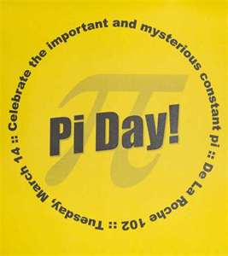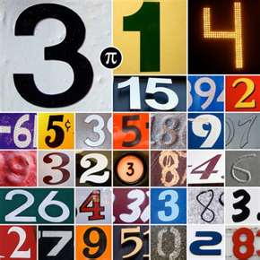
Pi is celebrated now
In its own special way
Every March 14th
Is known as “Pi Day”

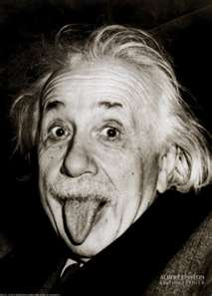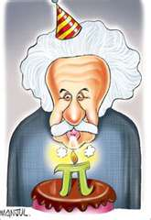

But I’ll tell you this
To keep you in line
It’s also the birth date
Of Albert Einstein!



Math games are played
Much fun is had
It’s no wonder Pi
Has become such a fad

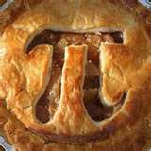

At the end of the day
I will strongly assert
A slice of pie
Is my tempting dessert

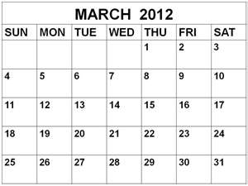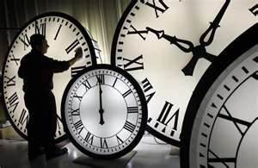

How we recognize this day
Bases all its stock
On the calendar date
And the hour on the clock


14thDay

The numbers 3-1-4
Many times we’ve seen
Encode the third month of March
And Day Number Fourteen


Whether a.m. in wee hours
Or p.m. in sunshine
Take note of the hour
Of 1:59

3/14 @
1:59:26
And if you wish to add seconds
“Tick-Tocking” twenty-six
You’ll have 3 point 1-4
1-5-9-2-6

3/14 & 7/22
Pi is celebrated
March 14th, that’s true
But another date in the year
Is July 22

22
This calendar date
Spells it out another way
That’s the 7th month
And the 22nd day

22/7 = 3.142857

Funny it may seem
To see this configuration
Until you recall
Pi’s famous approximation

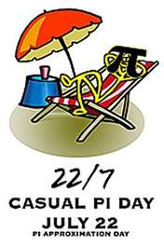

That’s 22/7
“Pi Approximation Day”
Pi on summer vacation
Not at work, but at play!

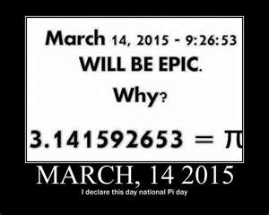

A future Pi Day
Has yet to be seen
The date of March 14th
In 2015

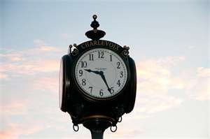

Keep track of the time
As the morning clock ticks
When it reaches the hour
Of 9:26

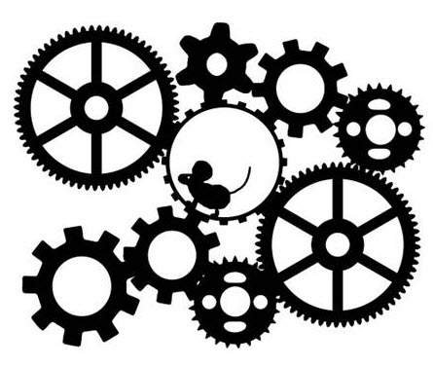
If precision of timing
Is your game and forte
Add 53 seconds
On that time of the day
3/14/15
9:26:53

And within this you’ll see
That Pi equals 3
Point 1-4-1-5
9-2-6-5-3

3/1 @ 4:15
DAY

The date of March 1st
At 4:15 can thrive
For this spells out
3.1415

November 10th
314th Day
November the 10th
Can make Pi Day “appear”
It’s the 314th day
Of the year
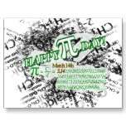
There are so many dates
We can put into play
That can make them pass
To be our beloved Pi Day
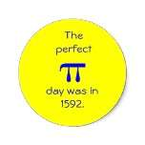
3/14/1592
But How I wish I did see
Oh Indeed I do
The date of March 14th
Of the year 1592!
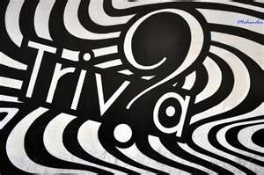

Pi’s practical use
Is all well and good
But here are some fun facts
In the trivia neighborhood



To know your hat size
It’s easier done than said
First measure accurately
The circumference of your head

Then divide by Pi
And the rest is a cinch
Just round off to the nearest
One-eighth of an inch



2 times Pi
Times the diameter of the foot
Measures the height of an elephant
Foot to shoulder, simply put

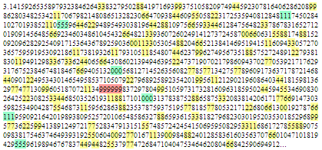

The “Feynman Point” digits
Are the same ones in line
And they go “nine-nine
Nine-nine-nine-nine”

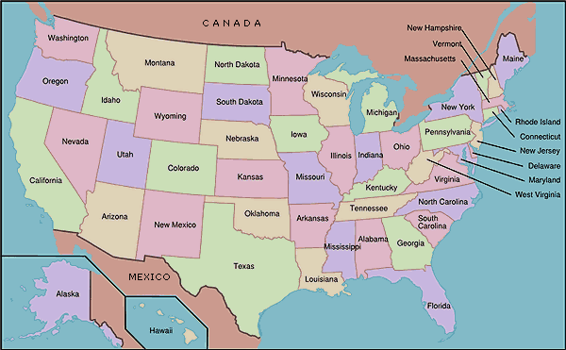

One billion digits
In ordinary writing
Stretch from New York to Kansas
Ain’t that exciting?

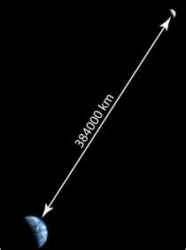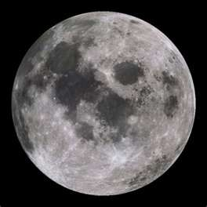

A billion bigger digits
Pointed up toward the air
Would stretch to the Moon
With more digits to spare

Ten digits to measure
Earth’s circumference is fine
But to measure the Universe
You’ll need thirty-nine

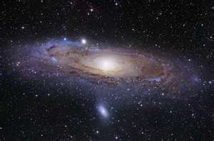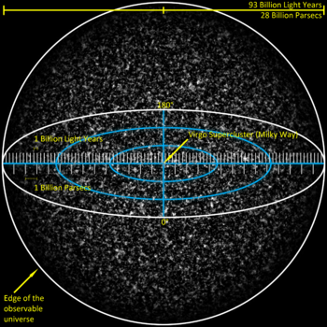

Those 39 decimals
Would surely fit
But you’d be slightly off
By one atomic bit

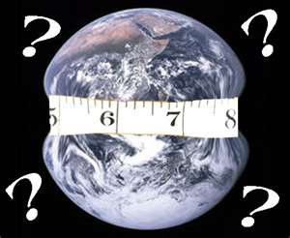

As for measuring the Earth
It is surely a cinch
Even though you’ll be off
By a fraction of an inch

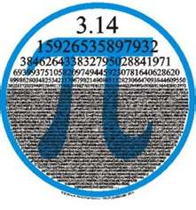
We recognize Pi
Almost always right quick
Especially those digits
In our minds they seem to stick

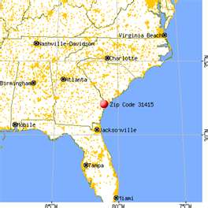

A ZIP code in Georgia
31415
Is the city of Savannah
Where you would arrive
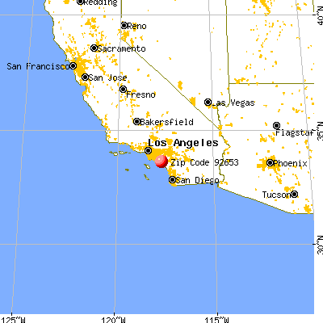

If you wish to continue
That digit string key
Go to Laguna Hills, California
ZIP Code 92653
.

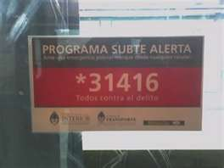

If you’re in Buenos Aires
And have some train trouble
Dial 31416
Help will be there on the double

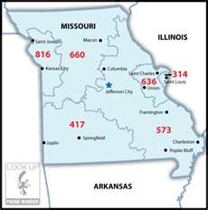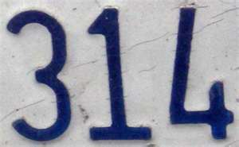

A phone call to Missouri
Area code 314
Would connect you to St. Louis
For a few cents more

(314) 159-2653

And I’ll bet some of you
Have tested your gall
Dialing Pi on your phone
Wondering who you might call!



The digits of Pi
Are frequently seen
In books, the media
Even the Silver Screen

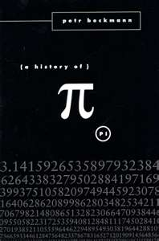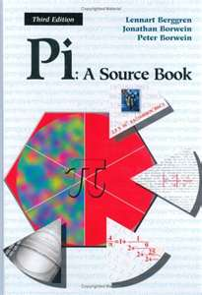

There are books on Pi
They’re there if you look
Such as “A History of Pi”
And “Pi: A Source Book”

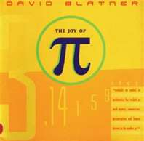

There’s a favorite of mine
Its sales were high
David Blatner’s work
“The Joy of Pi”
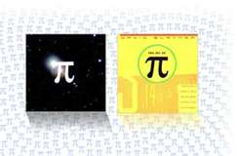
Read it straight through
Read it page by page
It’s truly a great read
For every age



One fictional novel
That sold fairly well
Was “Life of Pi”
By Yann Martel

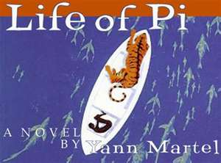

Having nothing to do
With the constant per se
The plot is poignant
In its own special way



A youth named Pi
Survives a shipwreck at sea
Alone in a lifeboat
With a tiger’s company

227 days ~ 22/7 = 3.142857

227 days
Was his journey’s duration
Hey, that number resembles again
Pi’s famous Approximation!
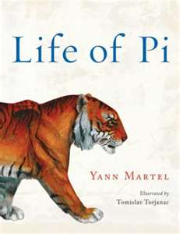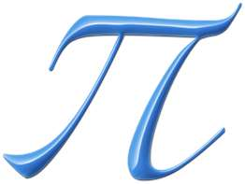

22 over 7 (22/7)
I can’t help but spot
The connection to Pi
And this book’s title and plot

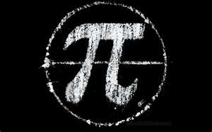

Books about Pi
Are complex and ponderous
But one book shows Pi
As mysterious and wondrous

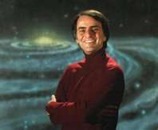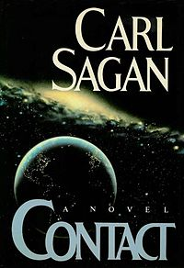

A message in Pi
If you think like a Vegan
Was implied in “Contact”
By Carl Sagan

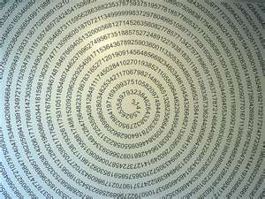

Is there a message in Pi?
No proof has been found
Although in the story
There appears in Pi… something round
CONSTRAINED WRITING

As far as words go
Here’s a cool Pi sighting
Writing them in “Pi-lish”
Or “Constrained Writing”

“Pilish”

HOW I LIKE A DRINK, ALCOHOLIC OF COURSE, AFTER THE HEAVY
3 1 4 1 5 9 2 6 5 3 5
LECTURES INVOLVING QUANTUM MECHANCICS
8 9 7 9

When writing words in order
Even you can give this a try
The amount of letters in each word
Represent a digit of Pi


Author Michael Keith
With his intellect so bright
Took this method “Pi-lish”
To such a great height

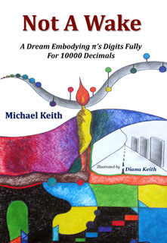

“Not a Wake” is his triumph
And if you wonder why
He used “Pi-lish” by embodying
10,000 digits of Pi

These are the digits of Pi
They are never wrong
They have even become a part
Of many a musical song



Kate Bush sings a song
Its popularity was high
The lyrics she sings
Are the digits of Pi



During O. J.’s Trial
There were arguments over Pi
Between Defense Attorney Blasier
And the FBI

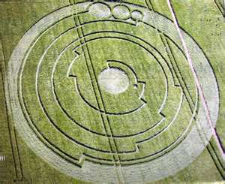

In two-thousand eight
A crop circle appeared
In a field in England
It was kinda’ weird

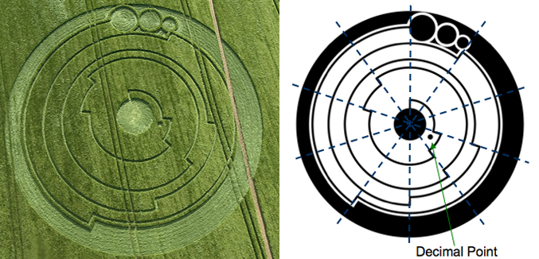

Upon close observation
We would soon find out
What the circle’s grid pattern
Was all about

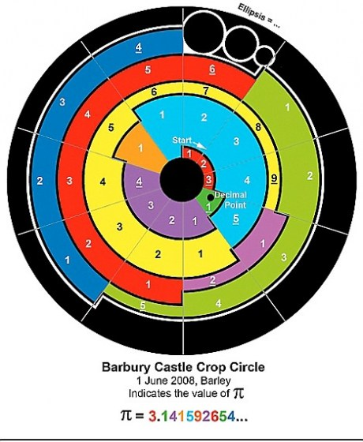

Starting at the center
And viewed from up high
Each grid means a digit
Of the constant Pi!

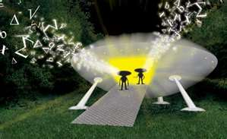

To some out there
This might be a clue
That aliens knowing math
Is probably true!
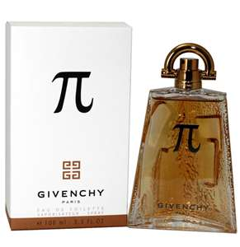

Pi is everywhere
We can’t leave it alone
Even Givenchy marketed it
As a man’s cologne

At last! What brilliance!
An ingenious spark
We nerds and geeks
Are no longer in the dark



The girls think all we do
Is study and read
But wearing the scent of Pi
We’ll attract them at light speed!

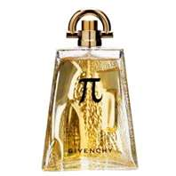

Masculine appeal can be worn
Time and time again
Even on highly intelligent
And visionary men



Weird Al’s music parody
Called “White and Nerdy”
May sound unorthodox,
And ridiculously wordy

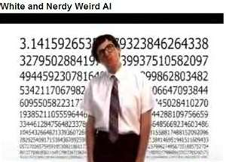

But in the music video
Of this wacky song
Appear the digits of Pi
And none of them are wrong

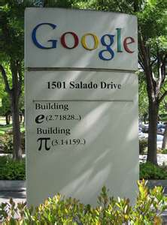

The Googleplex
Are corporate buildings in line
One of them is marked
3.14159

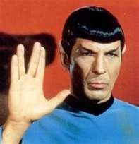

Star Trek’s Mr. Spock
When the computer went awry
Said “Compute to the last digit
The value of Pi!”

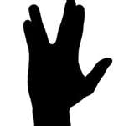

Spock foiled that computer
Victory did indeed occur
Thanks a million, Mr. Spock
Live long and prosper!



Spy network called “Pi”
Would make escape certain
In Alfred Hitchcock’s thriller
Entitled “Torn Curtain”



Typing the symbol Pi
Was Sandra Bullock’s bet
To gain access to data bases
In the movie “The Net”



Leslie Nielson’s sidekick
In “Spy Hard”, I adore
Was Nicolette Sheridan’s
Agent 3.14

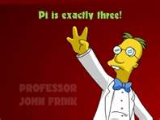

To get some attention
Professor Frink crowed
That Pi was exactly 3
In “The Simpson’s” episode

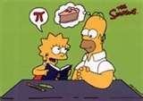

But don’t teach Pi to Homer
Do yourself a favor
‘Cause he’s liable to say
“Mmmm, Pie! What flavor?”



In another “Simpson’s” gig
Called “Marge in Chains”
Apu’s memory is tested
For how much it maintains

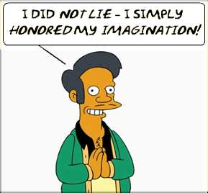

40,000 digits of Pi
He claims he can recite
Saying “the last digit is 1”
And evidently he’s right!

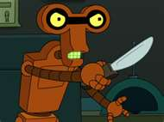

Called “π-in-1 oil”
Is the chemical product name
In the “Futurama” episode
“The Insane Mainframe”



In another episode
Called “Future Stock”
Pi yet receives
Another honorable knock



The Planet Express Ship
Flown by the Futurama crew
Passes a road sign saying
“πth Avenue”



The anime series
“Seraphim Call”
Showed in Episode 7
Something interesting for all

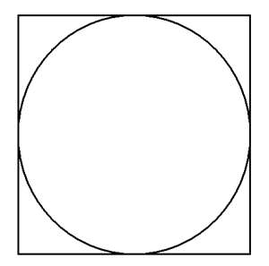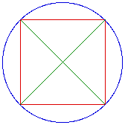

It was devoted to Pi
When it was broadcast on air
Focusing on the relationship
Between a circle and a square



In “Tales of the Abyss”
The video game
Our beloved constant Pi
Falls under another name



It’s the fonon frequency
Of the sentience “Lorelei”
3.14159…
The same digits as Pi

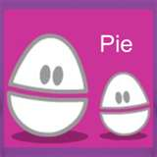

“Weebl and Bob”
First aired on MTV
The first episode was called “Pie”
That’s Pi with an “e”

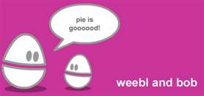

In the episode called “Riot”
Weebl triumphantly cries
“I only fight
For 3.14 Pies”

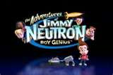

In a Jimmy Neutron episode
Jimmy fights the Nanobots
Who were designed to fix all errors
And there were lots

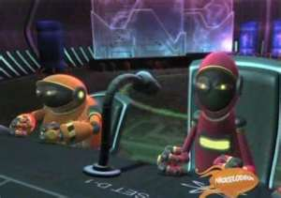

But to stop them from killing humankind
That means you as well as me
Jimmy forced them to correct a test paper
Which stated Pi equals 3
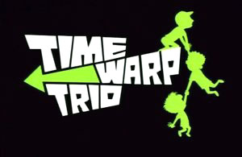

In “Time Warp Trio”
Sam makes a robot die
By telling the robot
That his number is Pi



In the French series “La Vache”
The main character in the flicks
Is a secret agent cow
Called Pi = 3.1416
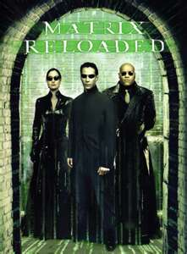

In the blockbuster movie
“The Matrix Reloaded”
Pi does not really appear
But its digits are encoded



314 seconds
Is the time window length
That Neo must reach a target
With all of his strength
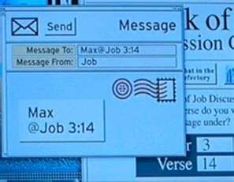

“Job 3:14”
Was the code name to use
To signal conspirators
In “Mission Impossible” with Tom Cruise



“Sure looks like Pi to me!”
The math world reckons
“This message will self-destruct
In 3.14 seconds!”



In “Scarface” Frank Lopez
Wore a Pi necklace to his end
Before Tony Montana said
“Say hello to my little friend!!!”

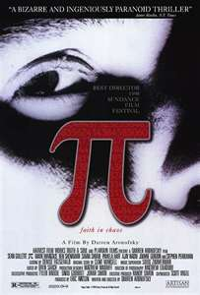

But my personal favorite
Is the movie “π” (Pi)
Director Darren Aronofsky
This I can’t deny

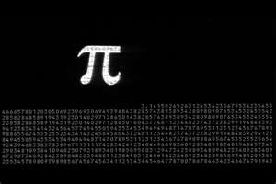

This movie was released
In 1998
It is surely a film
That many appreciate

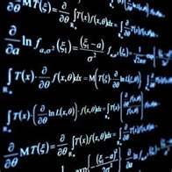

The paramount assumption
Sworn by all fanatics
Is that the language of nature
Is mathematics

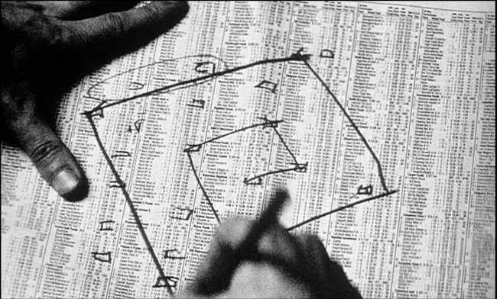

Max Cohen believed
Arranging numbers a certain way
Would produce key patterns
That have something to say

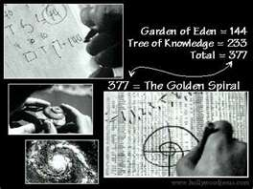

In the movie “Pi”
The mission Max Cohen had
Was finding patterns in nature
But it drove him mad

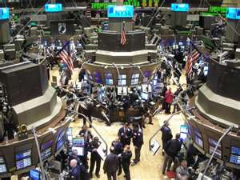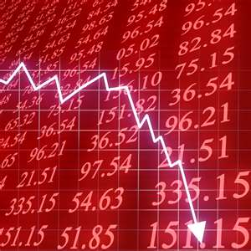

He believed number patterns
Were within close range
Even right on Wall Street
At the Stock Exchange



The answer Max thought
Was in a string he had seen
Of a bunch of digits
Numbering 216

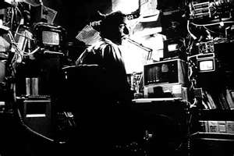

He ran the numbers
In his computer mainframe
But by the end of the film
He was never quite the same

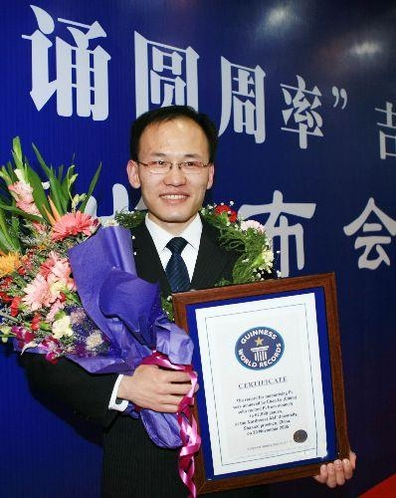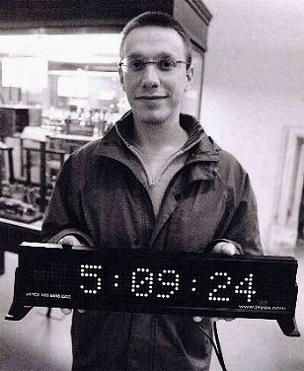

A chosen few of us
Have done our part
To memorize the digits
As many by heart

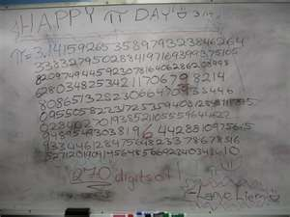

Many recited a hundred
Some a thousand and more
So many digits
Are beyond that “3 point 1 4”



We all declare
There’s nothing to it
Although many do ask
Why would we do it?

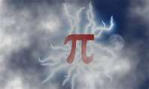

If for no better reason
Whether a challenge or a dare
We memorize Pi
Because it’s there!



As the climber scales
The heights to seek
That prize winning summit
That lofty peak

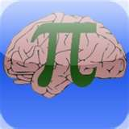

So we memorize Pi
Hoping well to gain
The limitless potential
Of our brain
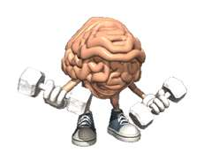
We respect all opinions
But reserve our right
To exercise our minds
To this admirable height



“Practice makes perfect”
That’s all it would take
It’s as easy as Pie!
It’s a piece a’ cake!

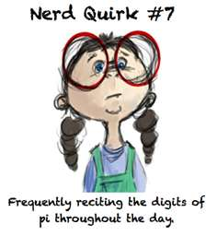
So strap yourselves in
I’ll shed some light
Listen to 100 digits
Which I shall recite

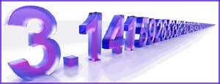

Include them with the rhythm
And make them rhyme
I have no doubt
You’ll have a good time
3 point 1 4
1 5 9 2
We’re far from over
I got more for you!

6 5 3 5
8 9 7 9
Just keep on going
You’re doing just fine

3 2 3 8
Don’t pause, don’t wait
4 6 2 6
This is real – no tricks

4 3 3 8
3 2 7 9
We can keep this up
It’s all yours and all mine

5 0 2 8
8 4 1 9
The rhythm is good
It’s right on the line

7 1 6 9
3 9 9 3
Learning’s good for all
Including you and me

7 5 1 0
Many more to go
5 8 2 0
Don’t go too slow

9 7 4 9
4 4 5 9
You can do it any day
Whether rain or shine

2 3 0 7
8 1 6 4
If that’s not enough
Well here’s some more

0 6 2 8
6 2 0 8
I remember them well
So far, that’s great

9 9 8 6
They’re all in the mix
2 8 0 3
They’re the way they should be

4 8 2 5
3 4 2 1
1 7 0 6
7 9We’re done!

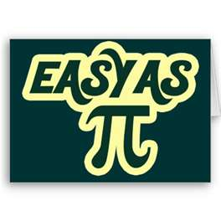
Memorizing Pi is easy
It can be a snap
If they’re all memorized
In that kind of rap

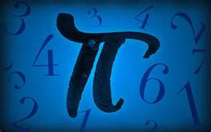

It was easy for me
It can be easy for you
Whether twenty, thirty
Or ten thousand and two
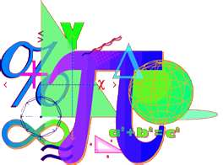

The same goes for math
Where Pi has evolved
All through the ages
We’ve all been involved

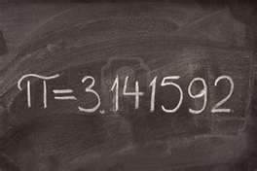

Our number so true
Pi, here’s to you
3 point 1-4
1-5-9-2!
THE AUTHOR

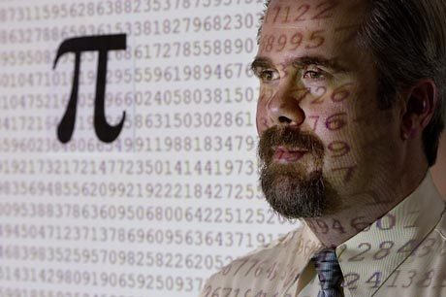

MARC A. UMILE, 45, IS AN AVID π (PI) ENTHUSIAST AND RECORD HOLDER FOR MEMORIZING 12,887 DIGITS OF π ΙΝ 2006 AND 15,314 DIGITS IN 2007.

Happy pi day!
March 14th (3/14)

